**PF Lab Task 4**

You are required to submit a zipped folder (named: yourRollNumber) containing a pdf file of section 1 & cpp files of section 2 (q1.cpp, q2.cpp..). There is no need for input validation.

**Section 1**

Read & understand pages 7 to 10 of **“Introduction to Ubuntu”** manual. Run all the given commands and attach the screenshots in a single pdf/word file.

**Section 2**

Write the C++ programs for the following question. All the questions must be implemented in separate cpp files.

1. Swap Two character variables.

2. Calculate the difference between two points.

a. distance=sqrt((x2 – x1)² + (y2 – y1)²)

3. Implement the quadratic formula.

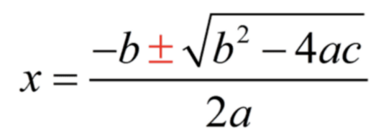

Please note that there will be two values of x.

4. Swap Two Numbers without using a temporary (third) variable.

5. Calculate & display Simple Interest

a. simple_interest = (principal * rate * time) / 100

6. Convert Fahrenheit to Celsius

a. celsius = (fahrenheit - 32) * 5 / 9

7. Calculate Area of a Rectangle, Triangle and Square